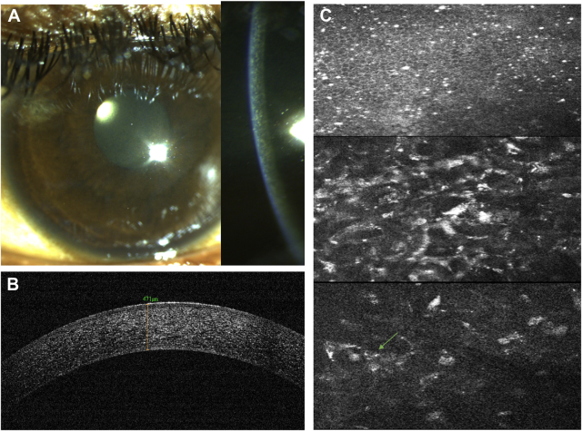

An 18-year-old man presented with gradual reduction of vision in his right eye for 3 months to 20/40 after sustaining trauma whileworking with a hammer and chisel. He underwent pars plana vitrectomy and foreign body removal. Rust-colored cornea (A) due to intrastromal and subendothelial brownish deposition (A, slit section) was noted. Anterior-segmentOCT showed hyperreflectivity within all corneal layers (B). Confocal imaging showed iron deposition in the basal layer of the epithelium(C, upper), anterior (C, middle), and posterior stroma (C, lower), and siderosomes as hyperreflective structures inside keratocytes. Based on the provided images and clinical description please make an ophthalmic diagnosis for this patient. And output the diagnostic conclusions only.

**Siderosis Corneae**